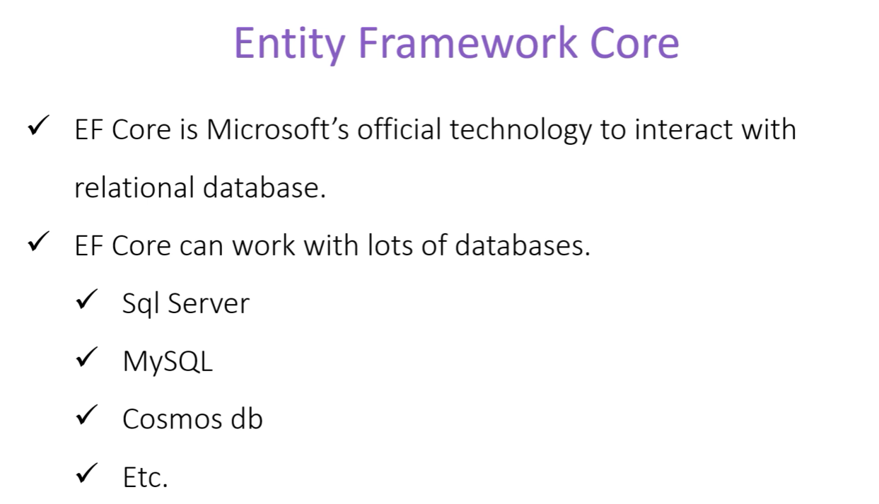We can use it with any .net technology not limited to asp.net core only.

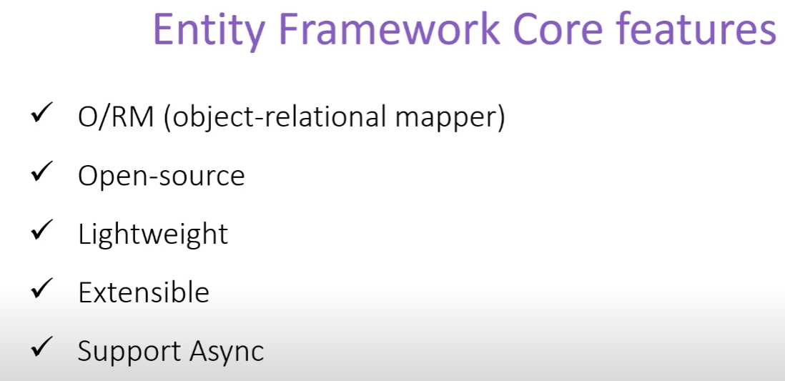

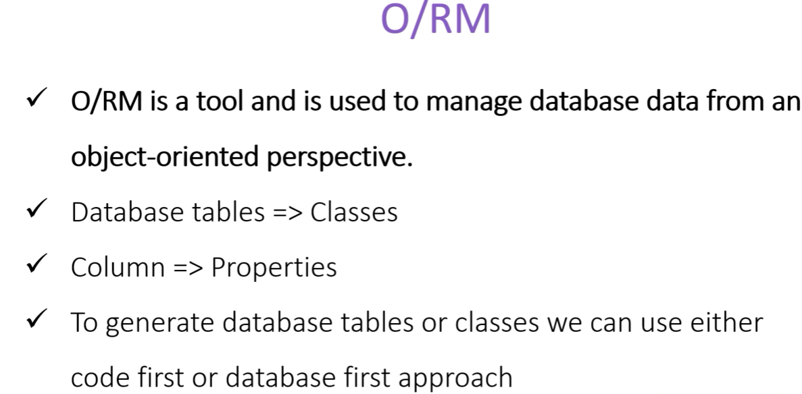

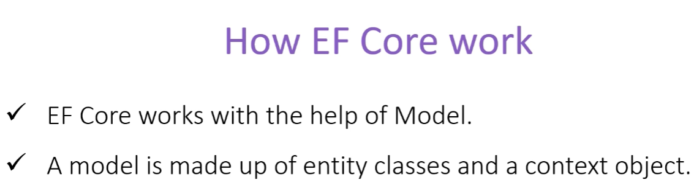

How to install:

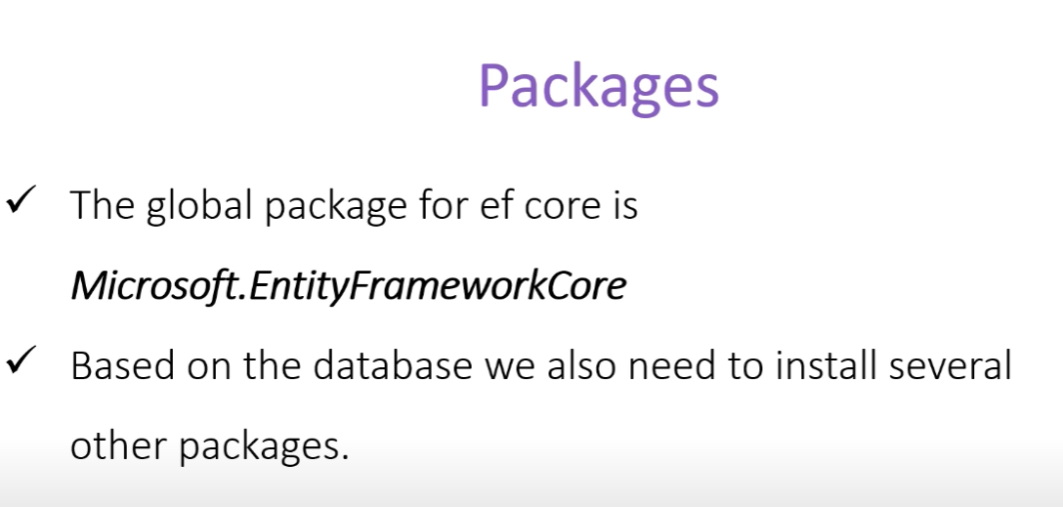

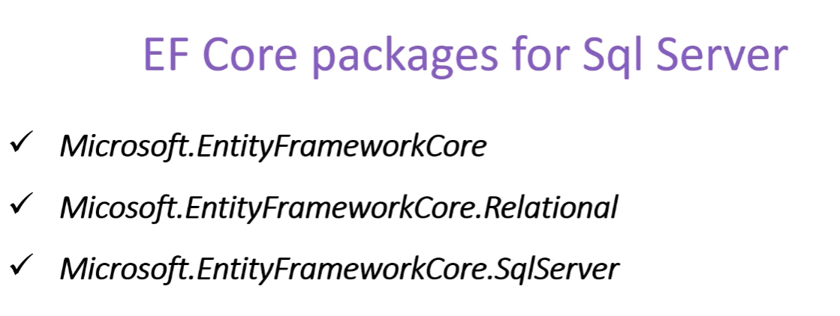

The last package have dependency on the first two packages, so if we install that, the other two packages will get installed automatically.

We need one more package , this package helps us with writing and executing the query for the EFcore.



For the other databases, the details can be found in the official docs.



We can install the required packages from nuget package manager.